Issues to Consider in Response to Proposals to Expand Eligibility
of The September 11th Fund

Summary
The purpose of this memo is to lay out some of the difficult eligibility issues the Fund has wrestled with, and explore how these issues may arise again if a portion of the remaining funds are not needed for the programs already authorized. We are not recommending any changes in policy at this time. Rather, we hope to prepare the Board for decisions you may need to make in the months ahead.
From its inception, the Fund has had to make choices about how broadly to provide help: Who has had the greatest needs, and how directly did they result from the tragedy of September 11th? Even with the unprecedented amount of money contributed to the Fund, it was clear from the beginning that we could not help everyone affected—even if the definition of “affected” was broadly drawn.
Thus far, help has been authorized for the injured, for the families of the deceased, for rescue workers, evacuees and witnesses, dislocated residents, workers, school children and communities affected by bias or hate crimes resulting from the attacks. In most cases, the Board opted to help those who were in the immediate area of the attack (e.g., displaced workers, small businesses, non-profits), but not always (help has been provided to the families of those who died no matter where they live). The Fund is continually urged to help others who were less directly affected. Examples include: those unemployed who worked elsewhere in New York, Washington or in other cities and those showing signs of stress who were not in the immediate area. If, with experience, it appears that existing resources will not be fully employed in current programs, the Board will again be faced with decisions how to use them.
The decisions this Board has had to make about eligibility always take into account the mandate of the Fund and the varying intentions of its millions of donors. In deciding how broadly to provide assistance to the economically dislocated, the Board approved aid for those whose livelihood was physically disrupted by the closing of lower Manhattan or National Airport, but not those who had worked elsewhere in New York or Washington, even in industries like travel and tourism that clearly were affected. When the staff recommended basing the Fund’s program on this distinction, we did so primarily because (a) we couldn’t show that New Yorkers working in these industries were affected differently from those working in the same industries elsewhere, and (b) the resources of the Fund were not large enough to offer a substantial program for everyone. Similarly, the Board approved mental health assistance for those who lost a family member and those who were in the area and fled, but not for those who lived or worked elsewhere within New York.
The basis for this geographic criterion was the federal cordon that prohibited vehicular and pedestrian access to the area for weeks. At the February 13th meeting, the Board reviewed these standards and added Chinatown and National Airport. The basis for doing so was that these areas suffered economic hardship following the September 11th attacks that was primarily the result of reduced access to the immediate area, rather than a general economic slowdown.
For this paper, we analyzed the economic dislocation outside the immediate area of the attacks (i.e., outside downtown New York). Outside the immediate area of the attacks, it appears that New York and Washington thus far have not suffered more than other cities. This seems to be because the attacks affected travel and tourism throughout the country, not just in New York or Washington. Most of the workers in those industries who lost their jobs were located elsewhere. However, as travel and tourism return elsewhere, the effects in New York may be longer lasting, since they involve other industries as well.
We also analyzed mental health needs. Here, it seems possible that more of those who were seriously affected may be in New York, and that a program limited to the New York area might be justified. There are as yet no national studies, but studies of Oklahoma City and other disasters suggest that those closer to the site of a disaster are likelier to be affected. However, other factors influence mental health as well (e.g., prior stress), and it is unclear how strong this effect may be.

Criteria: When Should the Fund Expand its programs?
Presumably, the Fund should expand its programs when it has confidence that the needs of those more directly affected are being adequately met and there are enough additional resources to do so.
To justify expansion of eligibility for assistance to NY/DC residents, but not others, would seem to require as well that the impact of September 11th – either in economic or psychological terms – be more significant in New York and Washington, DC, than in other regions. If not, it would be hard to justify providing help to New Yorkers or Washingtonians without enabling equivalent help for, say, residents of San Francisco or Chicago.
Complicating this are the varying views of our donors, who may view help to those hundreds of miles away and only indirectly affected as inconsistent with the Fund’s mandate. Some might say that such individuals and businesses are not “victims, families [or] affected communities”.
Presently, it is not possible to assess whether the Fund can expand its eligibility for services, since it is unclear whether sufficient resources will remain after the Ongoing Recovery Program has been implemented for the injured, for families of the deceased, and already-eligible residents and workers. Nonetheless, Fund staff continues to investigate whether residents of New York and Washington, DC metro areas have in fact suffered disproportionately as a result of the events of September 11th. The remainder of this memo summarizes that work to date.

Economic Dislocation

Original Eligibility Based on Physical Destruction & Access Limits
Where physical disruption did not occur, the Fund thus far has elected not to expand eligibility. Workers in the tourism and hospitality industries above Canal Street and outside New York who suffered job loss in the wake of September 11th do not receive Fund assistance. Although tourism halted, travel was cut back, and unemployment rose, at the time of the February meeting it was not clear whether these effects were September 11th-specific or related to the larger recession. There was also no data to assess whether airline or hospitality workers in New York had suffered more than their counterparts in other tourist and airline centers – Las Vegas, Orlando, Dallas, Honolulu, Seattle, Wichita, Washington, DC (to name a few). Given the sheer numbers of this group, providing assistance to all would have required more resources than were available in the Fund. The Fund therefore adhered to its direct economic impact criteria.
Nevertheless, the Fund continues to be pressed to consider expansion of eligibility to include others whose lives were significantly disrupted by the events of September 11th and who could benefit from some or all of the Fund’s case management, mental health, job training, health, legal or financial benefits. Some have proposed funding services to anyone who can substantiate September 11th related dislocation in the New York and DC metro areas, since these cities, they argue, were the centers of the attacks.

Analysis of Post-9/11 Economic Dislocation Outside the Immediate Areas of the Attacks
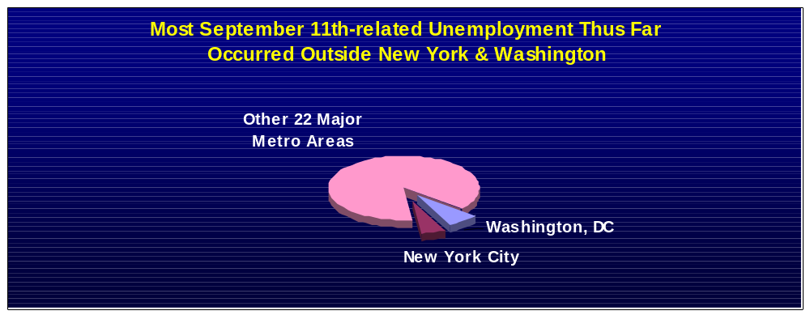The staff analyzed changes in post September 11th unemployment in major U.S. metropolitan areas to determine (1) whether the effects were substantial, and (2) whether unemployment was more severe in New York and Washington, DC, than elsewhere. The analysis took the form of multivariate regression comparing changes in unemployment rates in the six months after September 11th to those for comparable periods in earlier years, correcting for overall national trends in unemployment.
Unemployment rates rose substantially after September 11th throughout the nation, but particularly in cities with significant tourism, hotel, and airline industries. Based on the analysis, September 11^{th-}related unemployment amounted nationwide to approximately 875,000 jobs lost. However, only 5% of these were in the New York metropolitan area, and another 7% in Washington, DC; most of the job losses occurred elsewhere.
When unemployment is measured as a percentage of the population – i.e., an unemployment rate – New York ranks 22^{d} (DC ranked 16th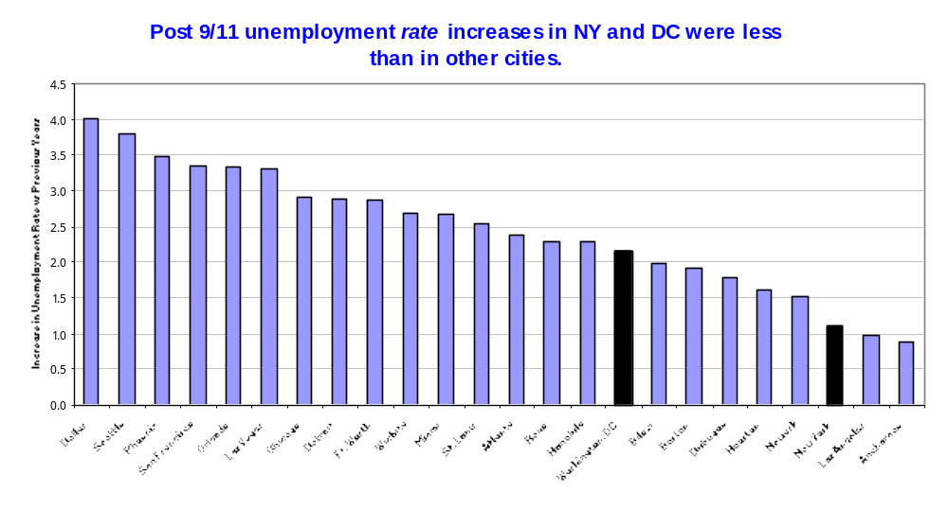), behind Dallas, Seattle, Las Vegas, Chicago, Wichita, Honolulu and several other cities where tourism and the airline industry factor more significantly into the local economy.
At this time, therefore, it appears that the job losses from September 11th occurred throughout the country, and that in places more dependent on travel and tourism those losses affected a larger share of the local economy.
Some project that New York City will be slower to recover job losses than other metropolitan regions. In part, they argue, the physical rebuilding that needs to take place in New York could delay economic recovery. In addition, the jobs lost in finance, insurance, real estate and retail trade sectors might be slower to rebound than those in travel and tourism. Staff recommends delaying a decision about the expansion of eligibility until hard data about employment recovery, in New York, DC, and the rest of the country, is available.

Mental Health Effects
The staff also sought out comparable mental health information on a national basis, which would make possible a similar analysis. After a great deal of staff investigation, we found no studies yet completed that collected any measures on a nationwide basis.
However, there are some studies, either local in nature or covering other disasters, that examine the relationship between psychological effects and geographical proximity. Reasoning by analogy, it may be true that those who lived closer to the WTC and Pentagon might be suffering disproportionate psychological distress. We are not sure that these studies, alone, provide the basis for a confident judgment, but want to make sure the Board knows about them and that we are continuing to watch the issue. More complete and relevant information may be available in the next 3-6 months, after other studies are complete, and when the Fund will also have a clearer sense of its remaining resources.

Limited Information from Other Disaster Studies
In general, the studies report that a disaster’s impact on a person’s emotional well being does correlate to some extent to his/her proximity to the site. The strength of the results, however, varies considerably.
- A study which compared the incidence of Post Traumatic Stress Disorder in two Manhattan locations one to two months after the attacks found that 20% of the population south of Canal Street experienced PTSD, compared with 6.8% of the population between Canal Street and 110th Street.
- A second study compared populations in Oklahoma City with those in a control city a few months and then 18 months after the bombing of the Federal Building. Stress was twice as prevalent in Oklahoma City and nightmares/bad dreams were almost three times as prevalent. Here again, both populations showed a decrease in symptoms after a year, but the levels stayed almost twice as high in Oklahoma City as in the control city.
- A third study looked at mental health impacts after 6 months in Australian populations following an earthquake which caused death and property damage. 18.3% of those close to the site showed evidence of Post Traumatic Stress Syndrome, vs. 2% for those further away.
- A public opinion survey in New Jersey compared the responses of those living within 30 miles of Ground Zero with those in another segment 70 to 150 miles away. Six months after the attacks, 42% of those closer in continued to worry about a future attack and feel that “life had not returned to normal”, versus 31% in the group further out. Both groups showed less fear as time passed, but the symptoms subsided more quickly in the farther population.
These studies show differences in psychological effects between geographically near and distant populations. However, it is unclear how strong this distinction will be for September 11th, because so many Americans experienced it as an attack on the entire nation. The geographical differences thus far do not approach the level found in Australia after the earthquake.

Views from Analysts of New York City Schools Survey
We also interviewed Dr. Michael Cohen and his colleagues, who conducted the survey of NYC public school students for the Board of Education. Based on that survey and others, they believe that the most important predictors of post-traumatic stress and other disorders are (a) actual contact with the disaster or a personal relationship with someone who died in it, and (b) prior life stress. They believe these are more important than geographic distance. We are continuing to work with Dr. Cohen and after months of negotiation have just received access to the information gathered from the survey itself.
Mental health experts report that emotional distress is as likely to worsen with time as it is to mitigate. The direct evidence of any prolonged psychological impacts of the September 11th attacks is not yet available either in the New York area or nationwide. We will continue to watch the situation to see whether identifiable separate needs arise.

